Streamlining Ticket Assignment For Efficient Support Operations

--Final Report

1. **INTRODUCTION**
   1. **Project Overview**  
      The Streamlining Ticket Assignment For Efficient Support Operations project focuses on building an automated ticket routing system using ServiceNow to improve IT service delivery. Traditional ticket assignments are often manual, error-prone, and result in uneven workload distribution, SLA breaches, and reduced customer satisfaction. This project aims to leverage ServiceNow's Flow Designer and automation capabilities to assign tickets based on issue types, enabling faster resolution, balanced workloads, and increased efficiency.
   2. **Purpose**  
      The purpose of the project is to design and deploy a centralized, low-code/no-code automation solution that can:  
      • Automatically route support tickets to appropriate groups based on predefined conditions.  
      • Reduce manual workload and assignment delays.  
      • Enhance SLA compliance, customer satisfaction, and agent performance.  
      • Demonstrate how ServiceNow's capabilities can solve real-time ITSM challenges beyond traditional configurations.
2. **IDEATION PHASE**

**2.1** **Problem Statement**IT teams face challenges with manual ticket routing, leading to inefficiencies, delayed responses, SLA violations, and unbalanced workloads. Lack of automation tools for ticket triaging further affects visibility, agent morale, and operational transparency.

* 1. **Empathy Map Canvas  
     Says:** "I'm constantly overloaded with tickets." "Why aren't tickets assigned fairly?"

**Thinks:** "Will I miss another SLA?" "There must be a more efficient way."

**Does:** Manually checks ticket queues. Handles multiple issues unaware of others' workloads.

**Feels:** Stressed and frustrated with the existing assignment logic.

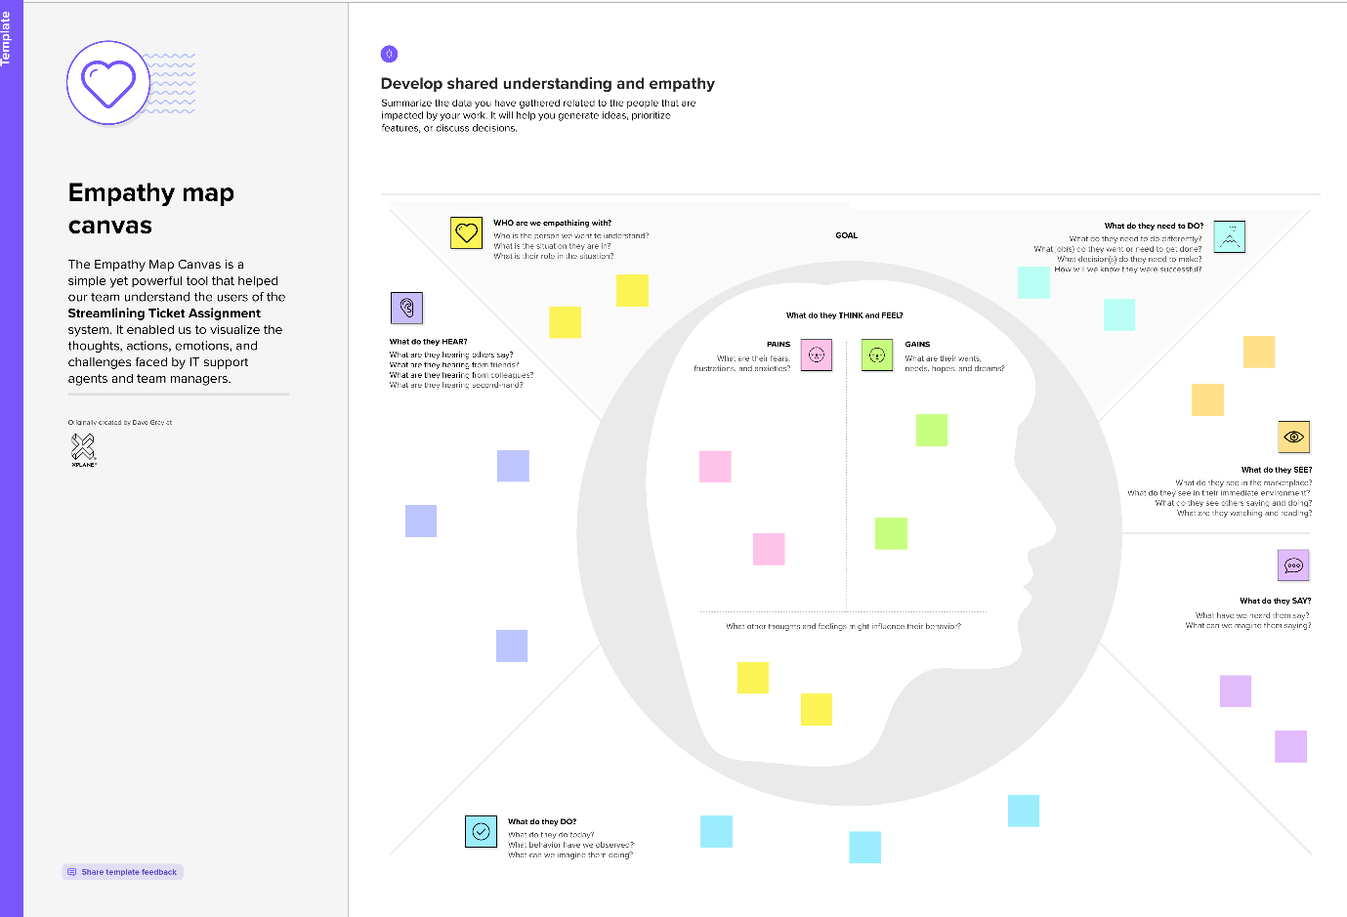+

* 1. **Brainstorming and Prioritization**  
     The team ideated around automated flows, custom tables, routing logic based on issue type, SLA monitoring, and notifications. Solutions were prioritized based on feasibility, automation potential, and business impact.

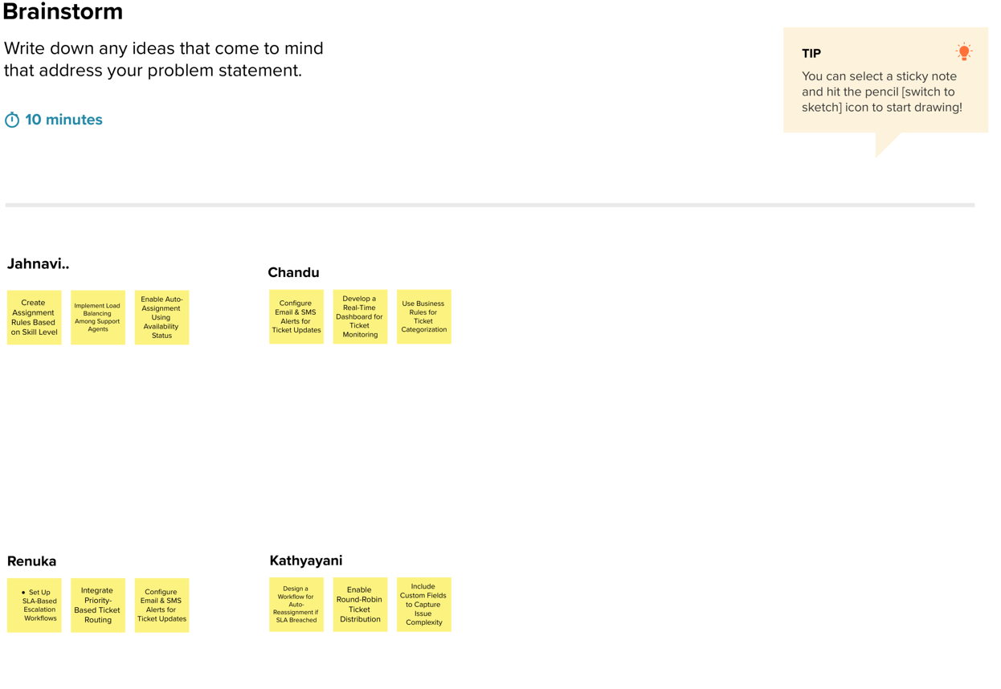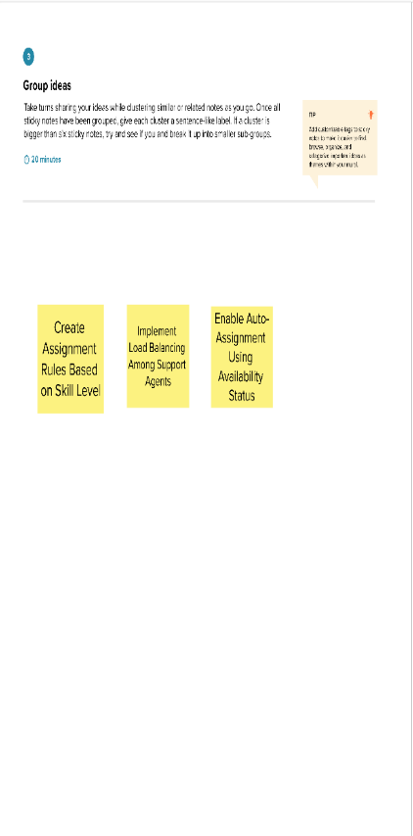

1. **REQUIREMENT ANALYSIS**  
   **3.1 Customer Journey Map**Users raise tickets → System captures issue type → Automated flow assigns ticket → Assigned group receives and resolves → SLA status is tracked
   1. **Solution Requirements**  
      • Operations Related table with issue types  
      • Choice field for routing logic (e.g., login issues, certificates)  
      • Users, Groups, Roles setup  
      • Automated flows using Flow Designer  
      • ACL and Role-based access control
   2. **Data Flow Diagram**

Ticket form → Validated input → Flow Designer evaluates issue type → Assign to group → Notify/Track progress

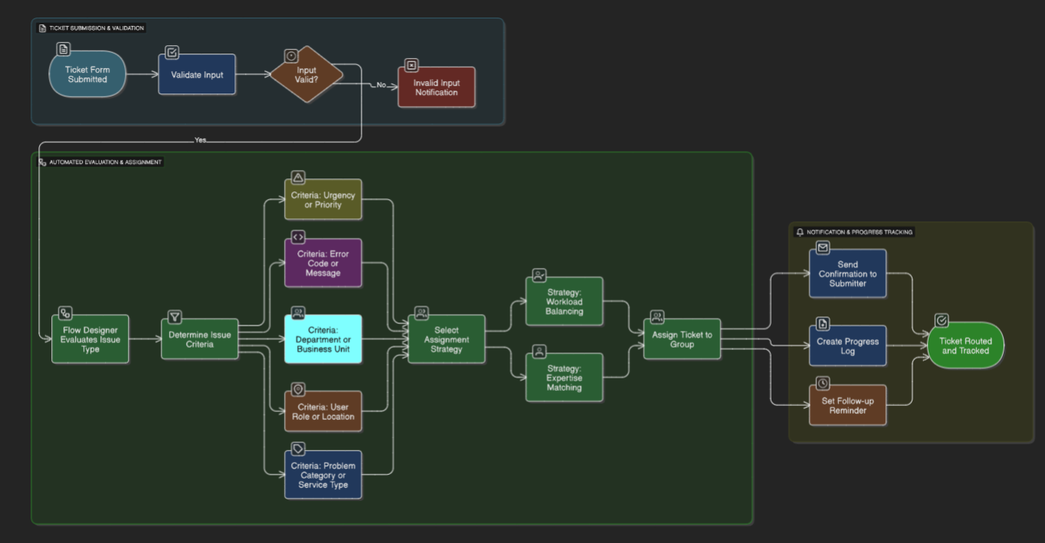

* 1. **Technology Stack**

• Flow Designer  
• Tables, ACLs, Roles, Groups  
• GlideRecord (optional for scripting)

1. **PROJECT DESIGN**

**4.1 Problem-Solution Fit**  
The solution resolves inefficiencies in manual ticket handling through rule-based automated routing, fair distribution, SLA alignment, and transparent tracking.

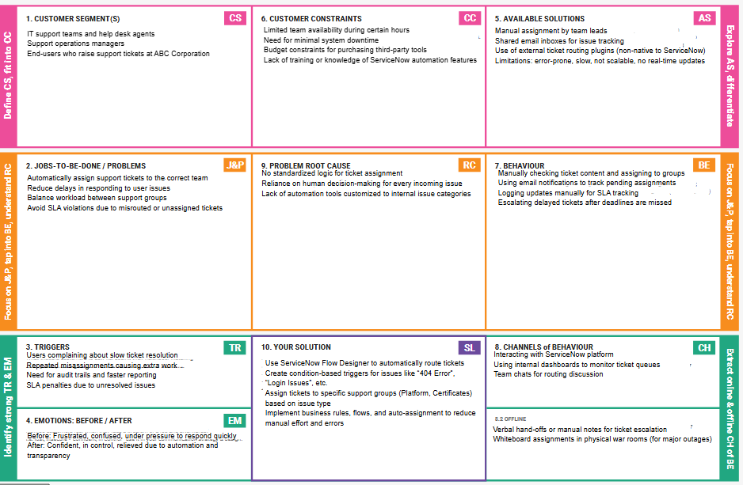**4.2 Proposed Solution Summary**

| **Identified Problem** | **Proposed Solution** |
| --- | --- |
| Manual ticket routing | Automated routing via Flow Designer |
| Unbalanced agent workload | Group-level routing based on issue category |
| SLA violations | Immediate routing reduces response time |
| Lack of routing logic | Transparent flow with rule-based criteria |

**4.3 Solution Architecture**

The architecture includes:

* + - Data Layer: Operations Related Table
    - Logic Layer: Flow Designer, Issue Criteria
    - UI Layer: Custom forms, issue selection
    - Security Layer: ACLs, Roles
    - Configuration: Update sets for versioning

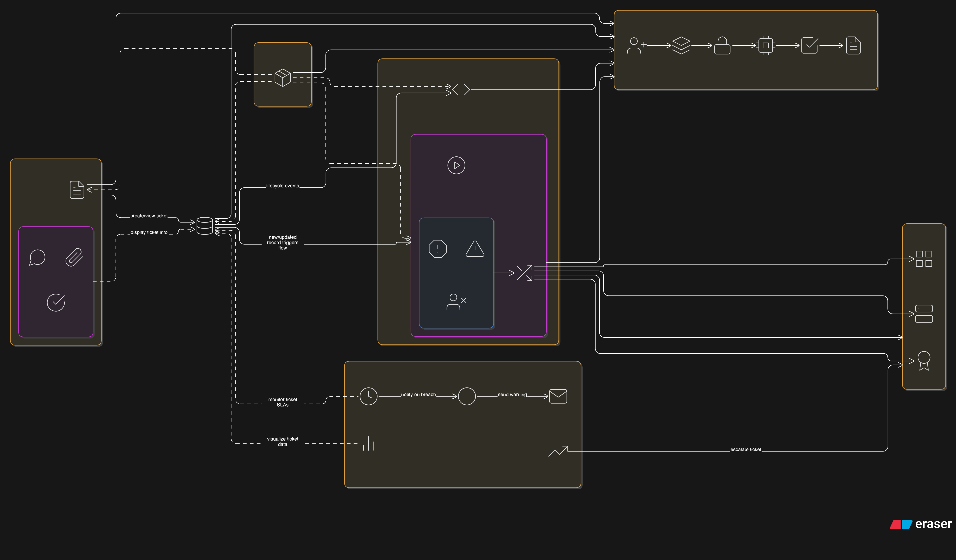

1. **PLANNING AND EXECUTION**

**5.1 Project Planning**

* + **Sprint 1 :(Instance Setup & Table Config - 6 pts)**

Setup PDI, Create Update Set, Create Operations table

* + **Sprint 2 :(User, Group, Role Setup - 9 pts)**

Create users, groups, roles, assign roles to users

* **Sprint 3 :(Access Control - 6 pts)**

Assign roles to tables, create ACLs

* **Sprint 4 (Flow Automation - 8 pts)**

Create flow for Certificate issues

Create flow for Platform issues (login/404/user expired)

Velocity: 29 points / 4 sprints = 7.25

**5.2 Milestones**

The project was completed as the following milestones covering 4 sprints

The team executed these milestones:  
**Milestone 1: PDI setup, instance ready**

* Sign up on [developer.servicenow.com](https://developer.servicenow.com) and create a developer account.
* Navigate to the Personal Developer Instance section and request a new instance.
* Fill out the required information and submit the request.
* Instance details (URL, username, password) will be sent via email.
* Log in to the instance using the provided credentials.
* The instance is ready for development and customization

**Milestone 2: User creation**

* Open ServiceNow by logging into your instance.
* In the left-hand navigation pane, click on "All" to expand the application list.
* In the filter search bar, type "Users" and select "Users" under the System Security module.
* Click on the "New" button to begin creating a new user.
* In the form that appears, fill in the necessary details such as User ID, First Name, Last Name, and Email.

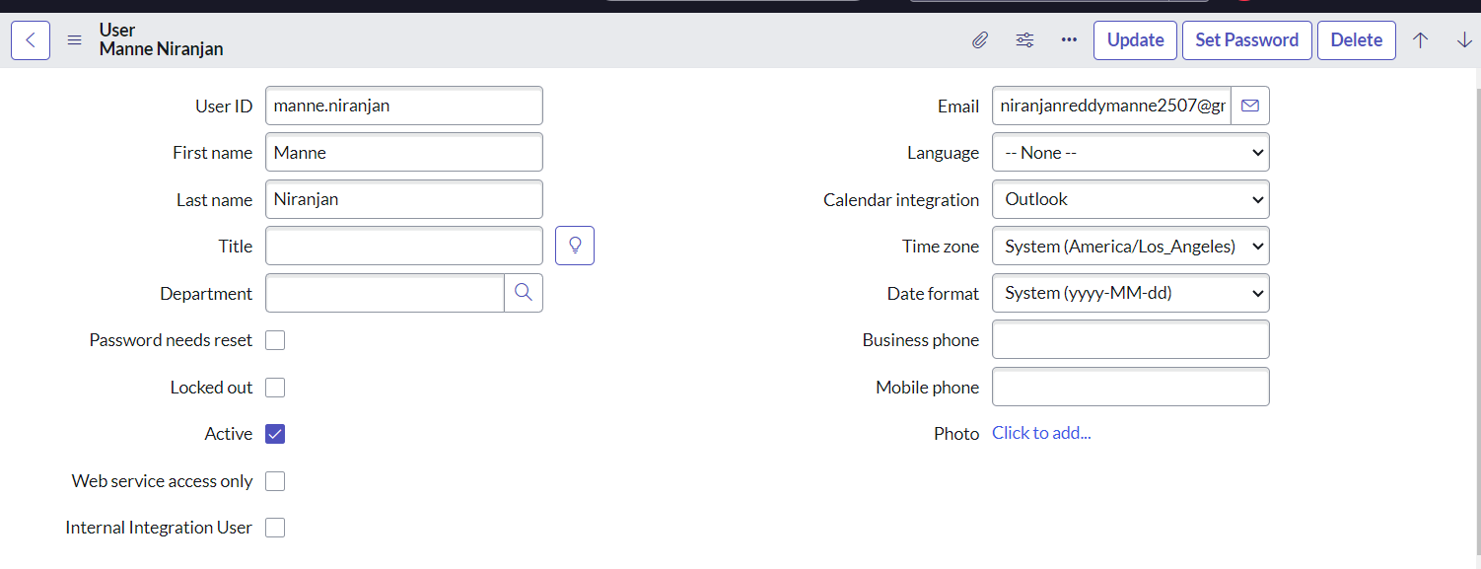

* After completing the form, click on "Submit" to save the new user.
* To create another user, click on the "New" button again.
* Enter the required information for the second user in the same manner.

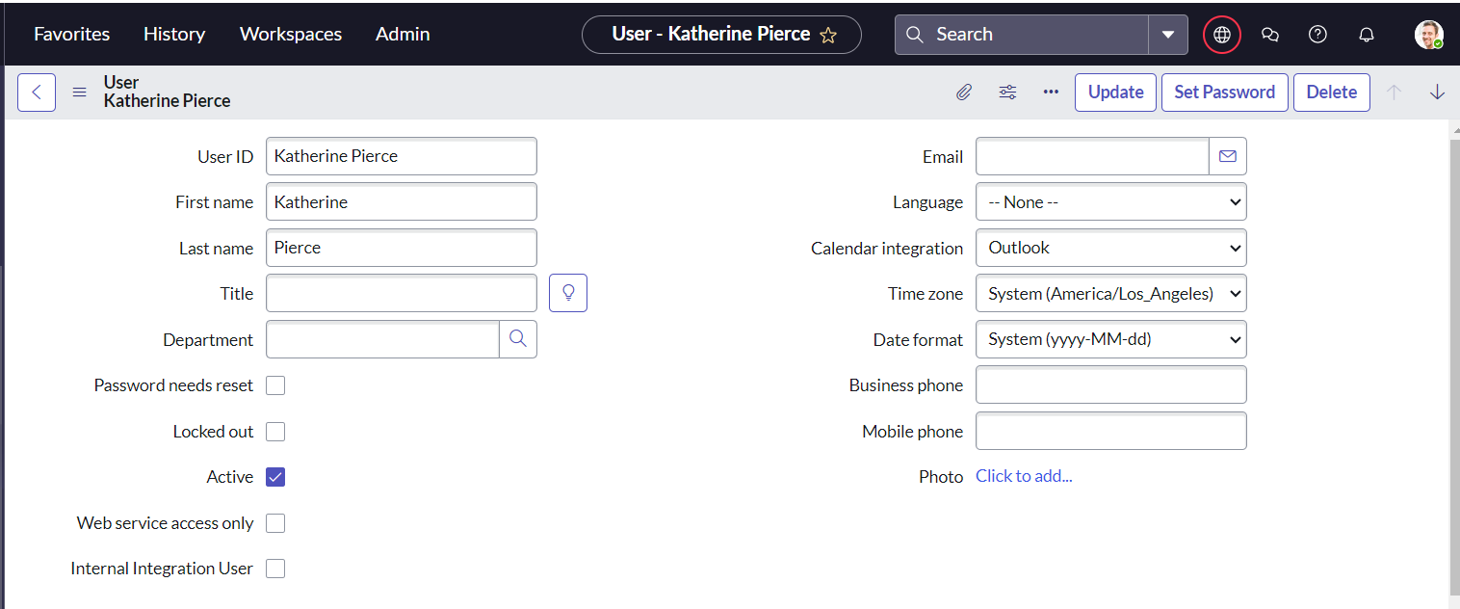

* Once all fields are filled, click on "Submit" to add the second user to the system.

**Milestone 3: Group creation (Certificates, Platform)**

* Open ServiceNow by logging into your instance.
* Click on "All" in the left-hand navigation panel to expand the application menu.
* In the filter search bar, type "Groups" and select "Groups" under the System Security module.
* Click on the "New" button to create a new group.
* In the form that appears, fill in the required details such as the Group Name and Description. 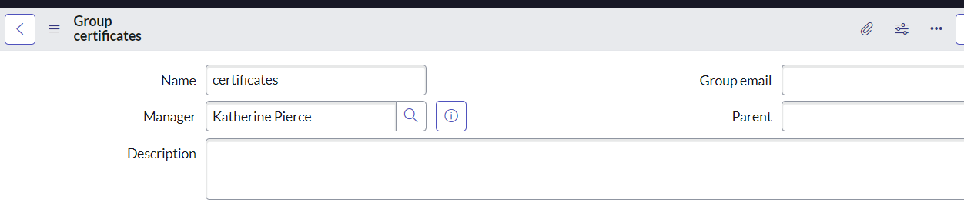
* Once the details are entered, click on "Submit" to save the group.
* To create another group, click on the "New" button again.
* Fill in the necessary details for the second group, just as you did for the first one.

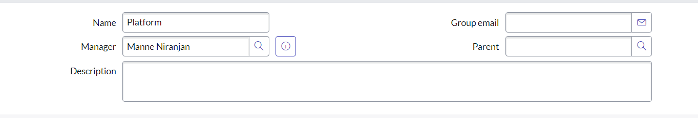

* After completing the form, click on "Submit" to save the second group.

**Milestone 4: Role creation and assignment**

* Open ServiceNow by logging into your instance.
* Click on "All" in the left-hand navigation pane to expand the application modules.
* In the filter search bar, type "Roles" and select "Roles" under the System Security section.
* Click on the "New" button to begin creating a new role.
* In the form that appears, fill in the necessary details such as the Role Name and Description.

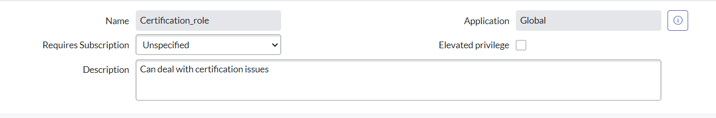

* After entering all the required information, click on "Submit" to save the new role.
* To create another role, click on the "New" button once more.
* Enter the relevant details for the second role in the form provided.

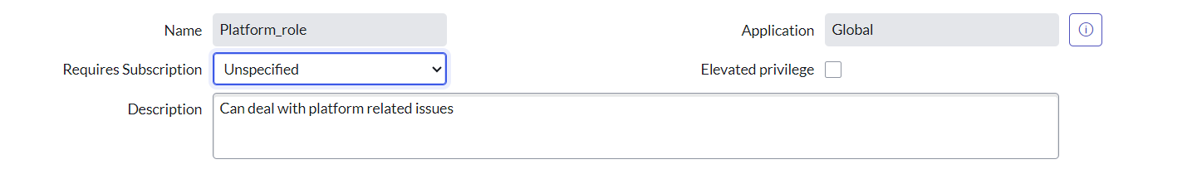

* Once completed, click on "Submit" to save the second role.

**Milestone 5: Table creation with issue choices**

* Open ServiceNow by logging into your instance.
* Click on "All" in the left-hand navigation pane to expand the application modules.
* In the filter search bar, type "Tables" and select "Tables" under the System Definition section.
* Click on the "New" button to begin creating a new table.
* In the form that appears, enter the Label as "Operations related".
* Check the boxes for "Create module" and "Create mobile module" to generate the respective modules automatically.
* Under the New Menu Name, enter "Operations related" to define where the module will appear.
* In the Table Columns section, define the required fields for your table.

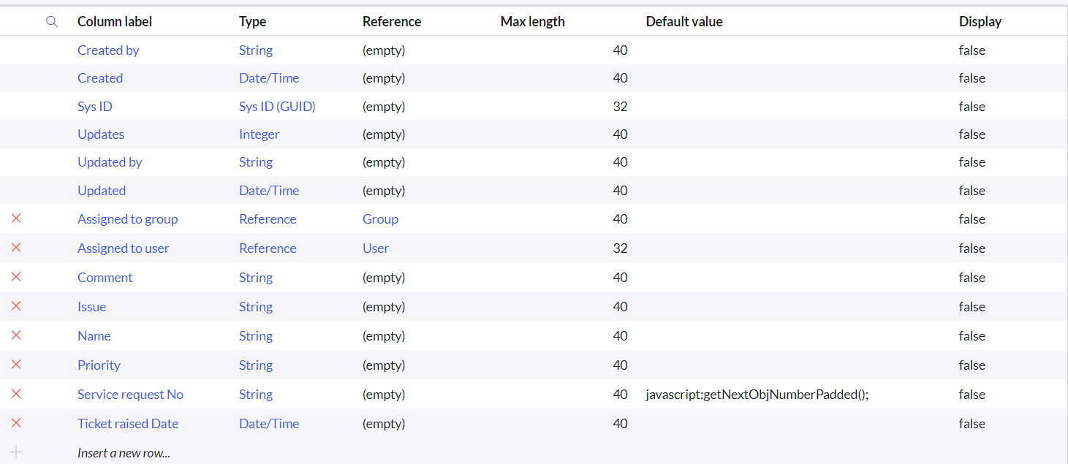

* After completing the form, click on "Submit" to save the table.
* **Create Choices for the Issue Field**
  1. Open the newly created table using **Form Design**.
  2. Locate the field labeled **"Issue"** or create a new field if it doesn't exist.
  3. Change the field type to **Choice** to allow multiple options.
  4. Add the following choices under this field:
     1. **Unable to login to platform**
     2. **404 error**
     3. **Regarding certificates**
     4. **Regarding user expired**
  5. Save the form to apply the changes.

**Milestone 6: Assign users and roles to groups**

**Assign Roles & Users to Certificate Group**

* Open ServiceNow and log into your instance.
* Click on "All" in the left-hand navigation panel to expand the application modules.
* In the filter search bar, type "Groups" and select "Groups" under the System Security section.
* From the list of available groups, select the group named "Certificates".
* Under the Group Members related list, click on the "Edit" button.
* In the user selection window, search for "Katherine Pierce", select her name, and click on "Save" to add her to the group.
* Next, navigate to the Roles related list within the same Certificates group form.
* Click on the "Edit" button under the Roles section.
* Search for "Certification_role", select it, and click "Save" to assign the role to the group.

**Assign Roles & Users to Platform Group**

* Open **ServiceNow** and log into your instance.
* Click on **"All"** in the left-hand navigation panel to expand the application modules.
* In the filter search bar, type **"Groups"** and select **"Groups"** under the **System Security** section.
* From the list of groups, select the group named **"Platform"**.
* Scroll down to the **Group Members** related list and click on the **"Edit"** button.
* In the user selection window, search for **"Manne Niranjan"**, select the user, and click on **"Save"** to add them to the group.
* Now scroll to the **Roles** related list within the Platform group form and click on the **"Edit"** button.
* In the role selection window, search for **"Platform_role"**, select the role, and click on **"Save"** to assign it to the group

**Milestone 7: Assign roles to tables**

* Open **ServiceNow** and log into your instance.
* Click on **"All"** in the left-hand navigation pane to expand the application menu.
* In the filter search bar, type **"Tables"** and select the **"Tables"** option under **System Definition**.
* From the list of tables, select the table named **"Operations related"**.
* In the table record, scroll down and click on the **"Application Access"** tab.
* In the list of access controls, click on the **u_operations_related Read** operation to open its configuration.
* Now, click on the **profile icon** in the top-right corner of the screen.
* Select **"Elevate Role"** from the dropdown.
* Choose **"security_admin"** and click on **"Update"** to elevate your privileges.
* Back in the Read operation form, scroll down to the **"Requires role"** section.
* Double-click inside the field to insert a new row.
* Enter **"platform_role"** as the first role and **"certificate_role"** as the second role.
* Click on **"Update"** to save the changes to the Read access control.

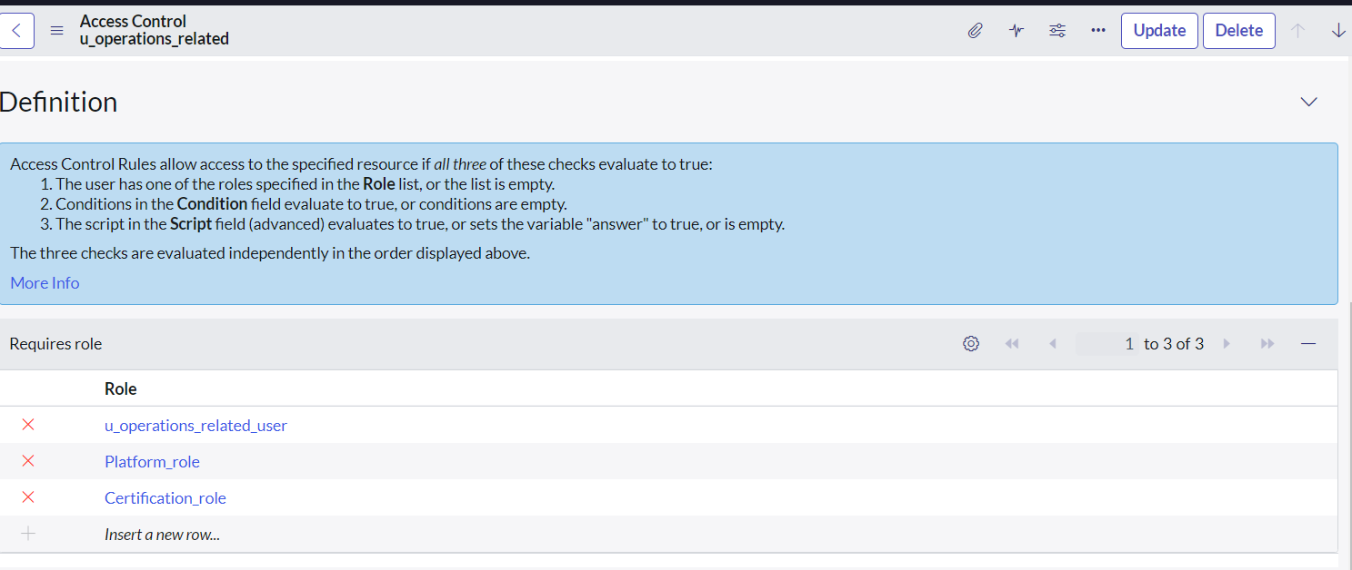

* Now, return to the access list and click on the **u_operations_related Write** operation.
* In the **Requires role** section, double-click to insert new rows.
* Again, enter **"platform_role"** and **"certificate_role"** as required roles.
* Click on **"Update"** to save the Write access control.

**Milestone 8: Create ACL for security**

* Open ServiceNow and log into your instance.
* Click on "All" in the left-hand navigation pane to expand the application modules.
* In the filter search bar, type "ACL" and select "Access Control (ACL)" under the System Security section.
* Click on the "New" button to create a new access control rule.
* In the form that appears, fill in the necessary details such as:
  1. Type: record
  2. Operation: read / write / create / delete (as applicable)
  3. Name: Select the appropriate table, e.g., u_operations_related or its fields

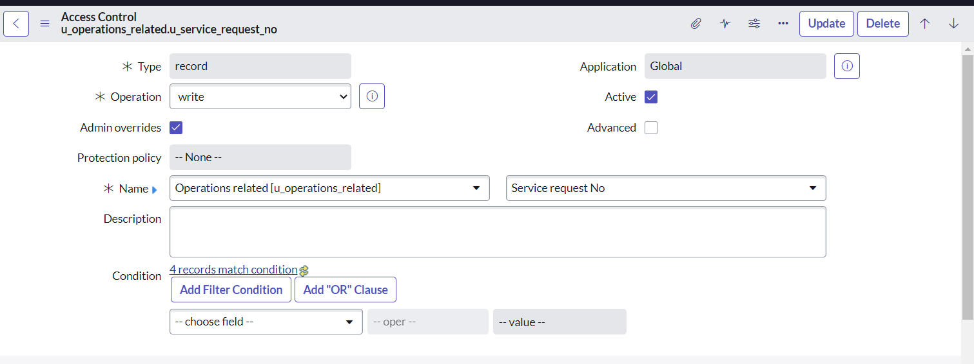

* Scroll down to the "Requires role" section.
* Double-click inside the empty field to insert a new row.
* Enter the role name admin to give administrative access.
* Click on "Submit" to save the ACL rule.

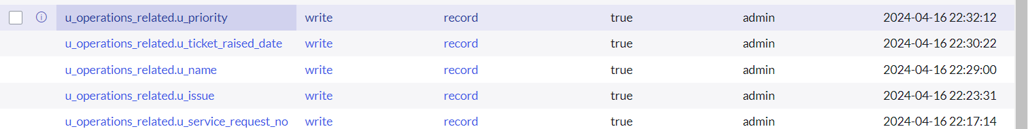

**Milestone 9: Automate ticket routing using Flow Designer**

**Assign "Regarding Certificate" Tickets to Certificates Group**

* Open ServiceNow, go to Flow Designer from the All menu, and click New → Flow.
* Name the flow "Regarding Certificate", set the application to Global, and choose System User as the Run As user. Submit to create the flow.
* Click Add a Trigger, choose Create or Update Record, select the table "Operations related", and set the condition where the Issue is "Regarding Certificates". Click Done.
* Click Add an Action, select Update Record, drag the record from the data panel, and set Assigned to group to "Certificates". Click Done.
* Finally, click Save, then Activate the flow.

**Assign Platform-Related Tickets to Platform Group**

* In ServiceNow, open Flow Designer and create a new flow named "Regarding Platform", set the application to Global, and the Run As user to System User. Submit to proceed.
* Add a trigger with type Create or Update Record, select table "Operations related", and set three conditions using OR logic:
* Issue is "Unable to login to platform",
* Issue is "404 Error",
* Issue is "Regarding User expired".  
  Click Done.
* Add an action of type Update Record, drag the record variable from the data panel, and set Assigned to group to "Platform". Click Done.
* Save the flow and click Activate to enable it.

1. **FUNCTIONAL & PERFORMANCE TESTING**

• Verified user creation, group linkage, and role assignments  
• Tested table creation, issue field options  
• Validated role permissions with ACLs  
• Successfully ran test flows for all issue types

1. **RESULTS & OUTPUTS**  
   • Certificates group receives tickets with “Regarding Certificates”  
   • Platform group receives tickets with login, 404, user expired issues  
   • Workload is distributed evenly based on logic  
   • Ticket routing is instant and accurate
2. **ADVANTAGES & DISADVANTAGES  
   Advantages:**• No-code automation via Flow Designer  
   • Reduced human errors  
   • SLA improvement  
   • Modular and scalable logic  
   **Disadvantages:**• Requires understanding of ServiceNow roles and flow logic  
   • PDI has time-limited access
3. **CONCLUSION**This project successfully automated ticket assignment in ServiceNow based on real-world support team challenges. The system is efficient, maintainable, and provides a scalable blueprint for future enhancements. Manual intervention has been minimized while SLA compliance and support quality have been enhanced.
4. **FUTURE SCOPE**• Add email/SMS notifications to agents  
   • SLA time tracking and escalations  
   • Visual dashboards for performance monitoring  
   • Skill-based agent assignment  
   • Integration with external systems